FSA Admin section for Documents from Vendor to have the Add\Edit section modified as follows:

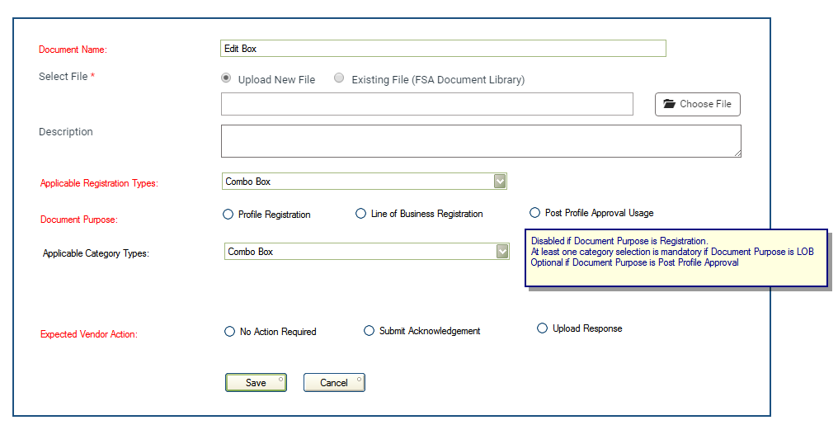

* Fields marked in Red are mandatory and needs to have the Red \* icon next to it
* The Applicable Category types is dependent on the Document Type selection
* Documents of Type “Profile Registration”

1. Such documents get displayed for the Vendor as soon as the initial profile submission happens
2. Documents which are marked as No Action have only View ability but no Upload or Acknowledgement actions
3. Only when all documents of type “Profile Registration” are acknowledged or uploaded and when Additional Data is updated, then the vendor profile displays to FSA for Approval Pending

* Documents of Type “LOB Registration”

1. Documents of this type get added to a vendor as soon as a LOB of the associated category is added by the vendor
2. Documents which are marked as No Action have only View ability but no Upload or Acknowledgement actions
3. For a vendor to be able to submit a LOB to FSA for Approval, at least one associated commodity should be available and the required actions on all documents related to that category must be completed
4. If a vendor registers a new LOB with the same category as one already present, then no new documents or actions are required since we already have everything

* Documents of Type “Post Profile Approval”

1. Such documents get displayed to a vendor as soon as the Basic Profile is approved for the first time
2. Documents which are marked as No Action have only View ability but no Upload or Acknowledgement actions
3. There is no impact on the vendor status or LOB status of such documents. These are purely between the vendor and FSA outside of the system but the application facilitates this

* A vendors ability to get reviewed and approved by FSA will be governed primarily by the following:

1. Basic Profile
2. Additional Data
3. Documents Required for Profile Registration

* A vendors ability to get their LOB reviewed and approved by FSA will be governed primarily by the following:

1. Basic Profile must be approved
2. Document required for that Category are available